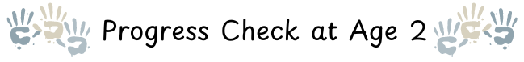
Name: |  | Date of Birth: |  | Key Person:

Communication and Language |  | Personal, Social and Emotional |  | Physical Development
What can I do now? |  | What can I do now? |  | What can I do now?
What I might do next with support? |  | What I might do next with support? |  | What I might do next with support?

I think (child’s voice) … |  | My family thinks (parent voice)…

Next Steps to support my learning and development in the setting |  | What parents/carers can do to support my learning and development at home

Signed Key Person |  | Signed Parent/Carer |  | Check moderated by:
Date: |  | Date: |  | Date:

