Body Map – Body

This form is to be completed at the same time (and attached to/stored with) the completed Record of Concern form or other relevant forms (e.g. accident/incident forms).
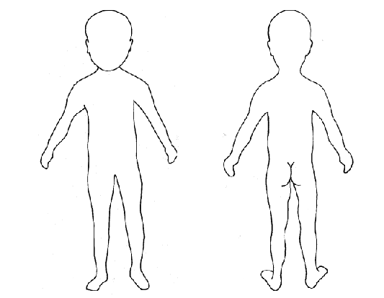
Child’s name: | Child’s date of birth:
Date & time of observation:

Staff name (print):

Staff signature: | Position in the setting:
Time and date record completed:

